**Telecom Churn Analysis**

**Team members  
Ankit Sharma  
Mayur K. Choudhari   
Arun Aherkar   
Appasaheb Thorat**

**Mahesh Patil**

**Abstract:**

Churn is major problem in any industry such problem is also observed in telecom industry. In given data we are looking for churn analysis for given data we first perform EDA and then by comparing various elements such as rates, voice mail, voice messages, international calls etc. By means of doing this analysis we can go for conclusion where is churn rate is high why customers are leaving. For a telecom industry it is very hard to acquire new customers so they should focus on how to retain existing customers.

**1.Introduction**

Usage of mobile devices has increased by a tremendous amount. In a survey conducted by the Socio-Economic council of United Nations, the world population was estimated to be about 7.7 billion users in 2019, with an almost equivalent number of cell phones. Several developing countries exhibit a penetration level of 97%–100%. This clearly depicts the stagnation in the market, as there are more cell phone connections than people. This makes market penetration very difficult, as the only way to acquire new customers is to make them move from one operator to another operator, hence leading to churn. Retaining existing customers was found to be relatively easy as obtaining new customers is found to be 5 to 6 times much costlier. Further, retaining customers and keeping them satisfied also leads to an increase in the customer base via referrals. Subscription-based organizations have higher concentrations on retaining existing customers and then on acquiring new customers who have a low possibility of churning. Customer churn in the state in which a customer moves away from an organization and towards another competitor. The process of customer churn not only leads to the loss of a customer but also leads to a reduction in the opportunity costs and also results in a negative impact due to negative views of word of mouth. The opportunity costs could be measured; however, the latter issue cannot be measured. Hence predicting churn effectively is a major requirement for any organization.

Customer churn- shifting from one service provider to the next competitor in the market, is a key challenge in highly competitive markets and is very much observed in telecommunication sector. Customer churns are those targeted customers who have decided to leave a service provider, product, or even a company and shifted to the other competitor in the market. Three types of customer churns - Active churner (Volunteer): those customers who want to quit the contract and move to the next provider. - Passive churner (Non-Volunteer): When a company discontinues service to a customer. - Rotational churner (Silent): Those customers who discontinue the contract without the prior knowledge of both parties (customer and company), where each party (e.g. customer or company) may suddenly terminate the contract without any notification.

**2.Problem Definition:**

Customer churn-shifting from one service provider to the next competitor in the market, is a key challenge in highly competitive markets and is very much observed in telecommunication sector. Customer churns are those targeted customers who have decided to leave a service provider, product, or even a company and shifted to the other competitor in the market. Literature reveals the following three types of customer churns:

- Active churner (Volunteer): those customers who want to quit the contract and move to the next provider.

- Passive churner (Non-Volunteer): When a company discontinues service to a customer.

- Rotational churner (Silent): Those customers who discontinue the contract without the prior knowledge of both parties (customer and company), where each party (e.g. customer or company) may suddenly terminate the contract without any notification

Churn prediction has been widely studied in the recent decade, particularly in the following domains: Open Social Network, Banking sector, Credit Card & a Financial Service provider, Online Gaming industry, Human Resource department of competitive organizations, Subscription service market, Question and Answer Q&A forums and Insurance service providers. It is clear from this discussion that customer churn as a problem is crucial for various organizations. Simultaneously, customer churn problem is rapidly being observed in telecommunication industry around the globe as well.

**3.EDA on given Data set**

Digging into data we understand that

* There is no null value in the data set.
* In state column there are total 51 unique states.
* Total 20 columns with values such as float, integer, Boolean and object.
* Dependent variable should be considered as Churn.
* Graphical representation according to various columns and with manipulation of columns.
* By manipulation of columns we can find average price for day, evening, night, international.

As the data analysis is one of the important parts in EDA in this data set there is no need of data manipulation as there is no null values in data set. The given data cannot be shown virtually or graphically as it is because it is a large data set.

For this problem we need to go for group-by operation in which we are grouping states and manipulating columns for case of columns we need to take mean of all values and put it into graphs. From manipulation it is seen that the states which are moving towards churn are not approaching towards customer service.

instead when customer put request customer service should reach towards them to solve their problems.

**4.Churn percentage of states (EDA)**

From pi chart we can see churn percentage is about 14.5% which is more. We have to look for the customers who are leaving the company or not satisfied with the results of the company.

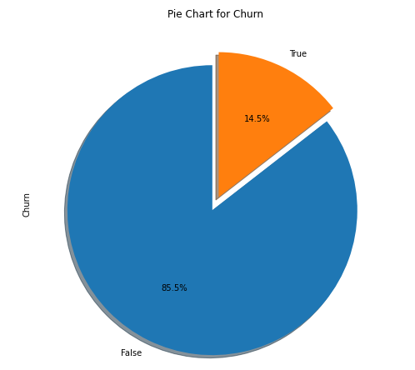

Fig 1: Pi chart of customer churn.

We have to look for the usage of the different calls provided by the company and used by the customers. The graph below shoes total use in particular day consumed by customers. From the graph below, we can see it is a multiline plot in usage of customers is given here we can see total day usage is more as compared to the night usage and evening usage and international calls are used less also.

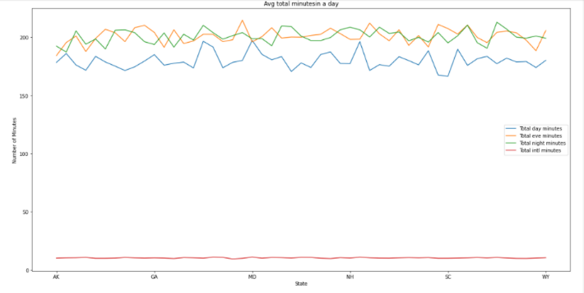

Fig 2: Multiline plot of customers usage and minutes.

**5.Relation between Churn and Others**

As we are looking for the customer churn, we have to consider which customers are churning most. From scatter plot we can see there are mix match behaviour of customers in case of night and evening calls but customers who are using more day calls have more percentage towards churn. From multiline plot given below we can see which customers is generating more amount of revenue for company.

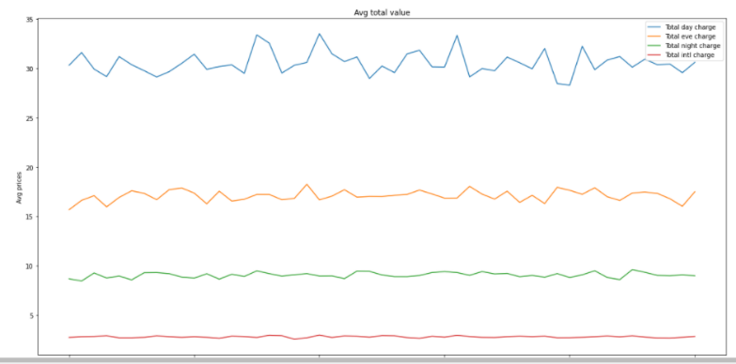

Fig 3: Multiline plot of customers usage and charges.

From above graph we can see more revenue is generated by day customers as well as from scatter plot it is seen that day customers with high usages are moving towards churn more.

With the consideration of prices international calls have more price then other plans. Churn rate for international customers are more as call minutes increase for this case company come with the balanced price list such as it should not be more for day and lea for night.

If the churn rate of company is 50% then the company will be going to shut in two years. As company with churn rate 25% then it will shut in four years so Churn is the major factor to be taken in consideration.

**6.Conclusion**

From the given data and after performing EAD and comparison with the all the elements we say that there are some factors which company should take care in consideration.

* States with high percentage of Churn are not approaching towards customer service center. Instead when port request is put by some customers customer service should approach them.
* There is mix match churn rate for voice mail plans and voice mail messages.
* People with international plan who use more international minutes are moving towards churn.
* Due to high day charges people who use day minutes more are moving towards churn. As of that we would like to suggest take fix price for all types of times or lower the charges for day and increase for evening and night.
* For a telecom company it is necessary to approach towards customers on ground level and within certain period of time launch new schemes.
* States where customers churn rate is high increase advertisement in that area and increase customer service centers.

If the churn rate of company is 50% then the company will be going to shut in two years. As company with churn rate 25% then it will shut in four years so Churn is the major factor to be taken in consideration.